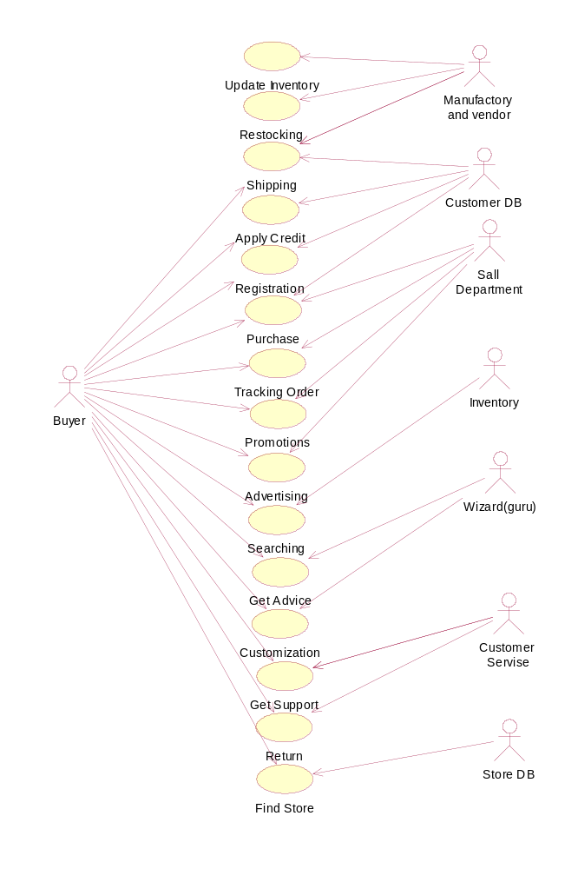
Factors Contributing to Project Success According to Standish Report:
1. Executive Management Support
2. User involvement
3. Experienced Project Manager
4. Clear Business Objectives
5. Minimized Scope
6. Standard software Infrastructure
7. Firm Basic Requirements
8. Formal Methodology
9. Reliable Estimates
10. Other
The cost of incorrect, misunderstood, and not agreed upon requirements affects the customers and developers in terms of time, money, and lost opportunities.

Applying the CHAOS Ten in our project
User Involvement:
Identified the Users and Customers:
- Stakeholder and User description in the Vision Document
Gathered needs from Users and Customers:
- Role Playing
- Interviews
- Questionnaire
- Brainstorming
- Regular Meetings
Clear Business Objectives:
Identified the following in the vision document:
- Business Opportunity
- Problem Statement
- Product position Statement
- Product Perspective
- Product Overview
Also performed:
- Market Analysis
- User Background Analysis
Minimized Scope:
- Defined Deliverables
- Defined Functionality
To help you define your scope, answered the following questions:
- What processes (and what are not) are included in the scope of our project? Where does each process begin and where does each process end?
- What systems (and what are not) are used in these processes are included in the scope?
- What organizations (and what are not) involved in these processes are included in the scope?
Standard Software Infrastructure:
- Indentified the following in the Vision Document:
- System Requirements:
- Language, Operating System, Platform
- Performance/Reliability Requirements:
- Constraints
- Quality Ranges
- Product overview including assumptions and dependencies
Firm Basic Requirements:
Elicitation:
- Statement of work/task definition.
- Interviews
- Group brainstorming.
- Observation.
- Questionnaires and/or surveys.
- Prototyping
Approval process for all the requirements for both functional and non-functional requirements
For interpreting and agreeing upon requirements, in weeding out requirements not considered, identifying potential or real bottlenecks, or deriving requirements we used:
- UML collaboration/communications diagram.
- UML state chart diagram.
- UML sequence diagram.
- UML activity chart.
Traceability of requirements:
- Each Use Case used (in the Functional Requirements) can be traced back to the respective requirements of the project.
- Each Non functional requirement can be traced back to the features represented in the Vision Document.
- Requirements can be traced back to the Product Features defined in the vision document.
- Each Feature can be traced back to the wants and needs of individual customers (which were generated in the elicitation processes).

Find Store(Store Location Service)
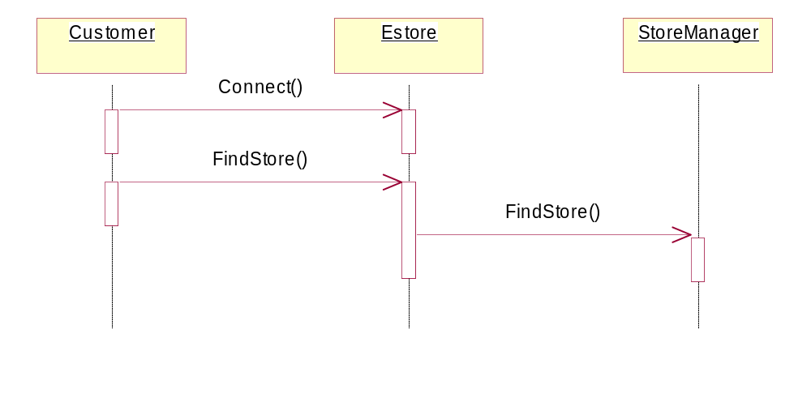

Return(Return Policy)
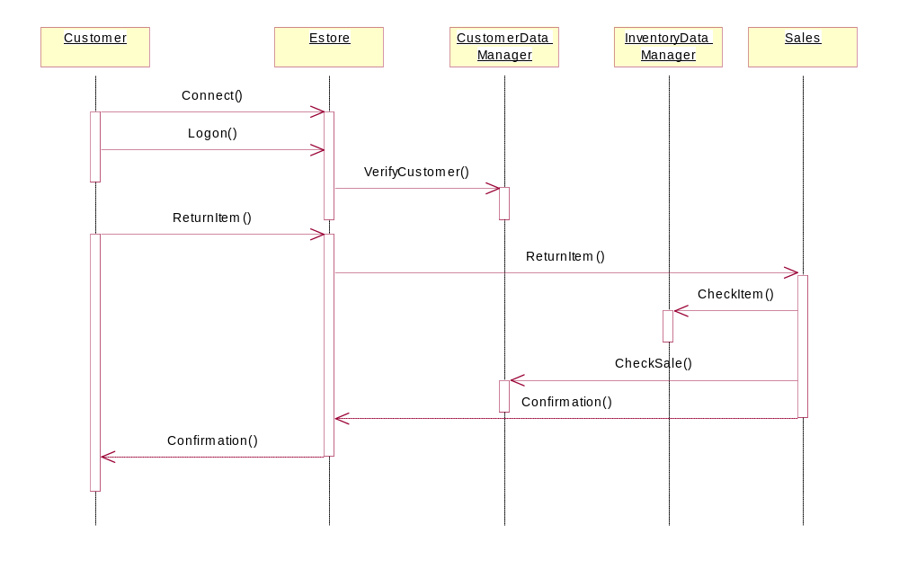

Get Support(Customer Support)
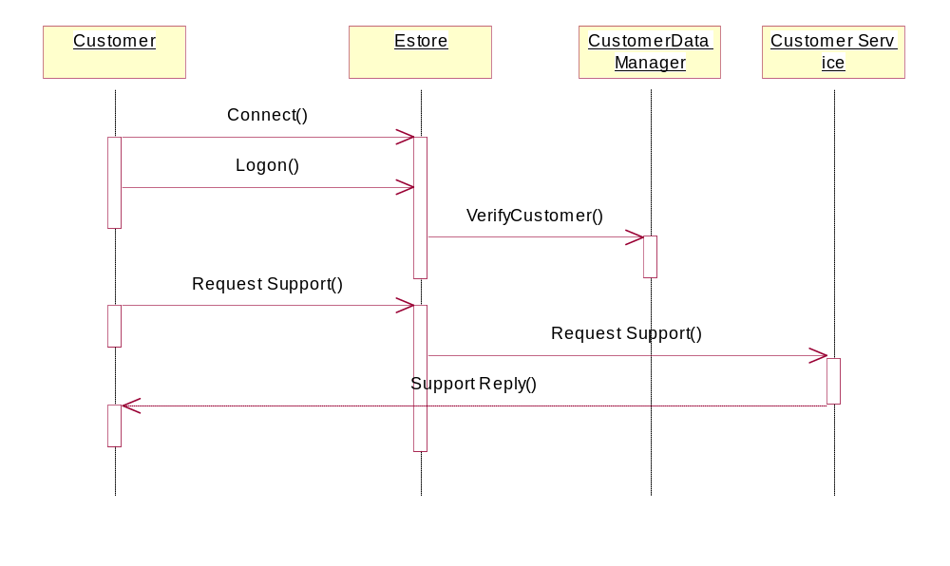

Customize (Configure products online)

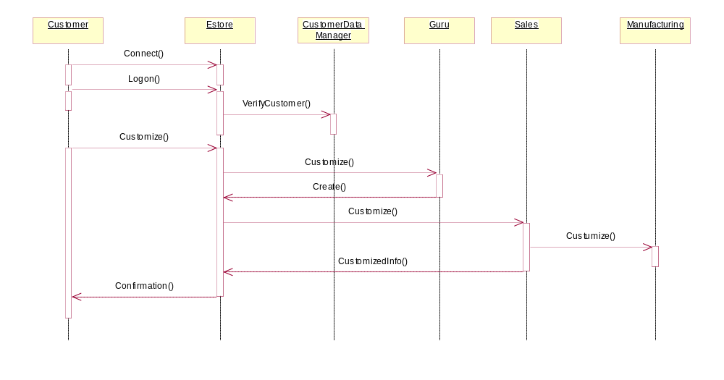

Get Advice(Help/Cfg Wizards)
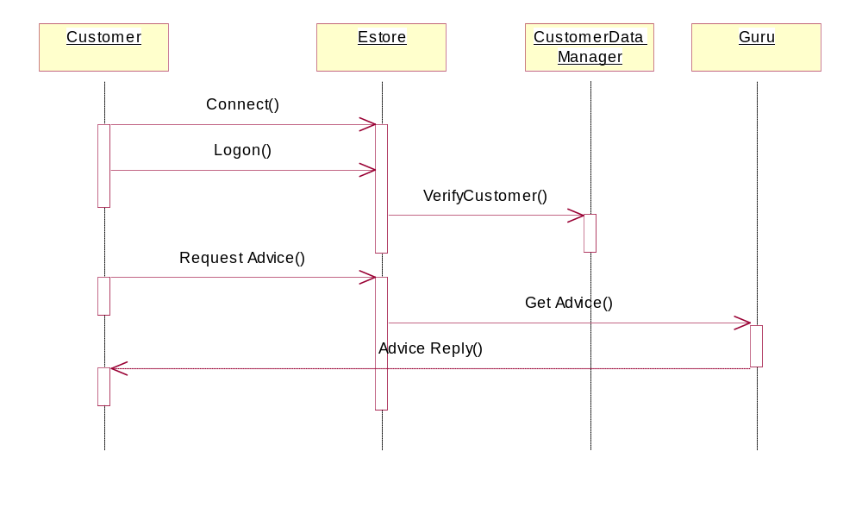

Searching (Provide a searchable online catalog, Inventory Tracking)
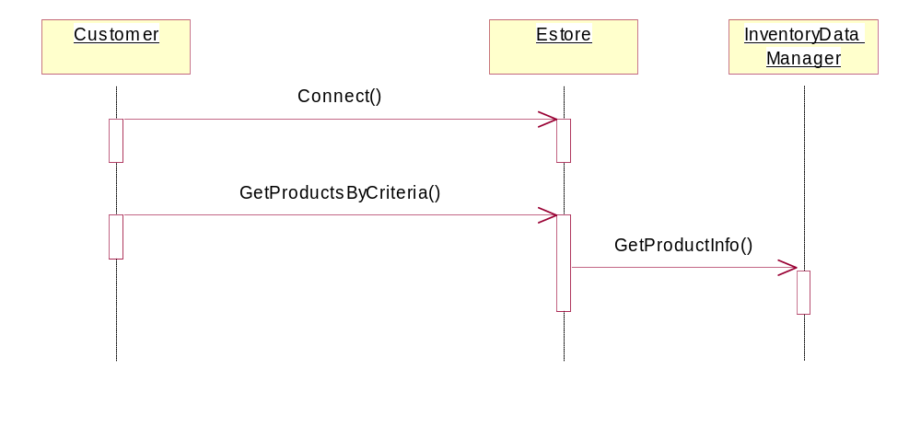

Advertising(Company logo,links,Specials, Highlights, Cookies)
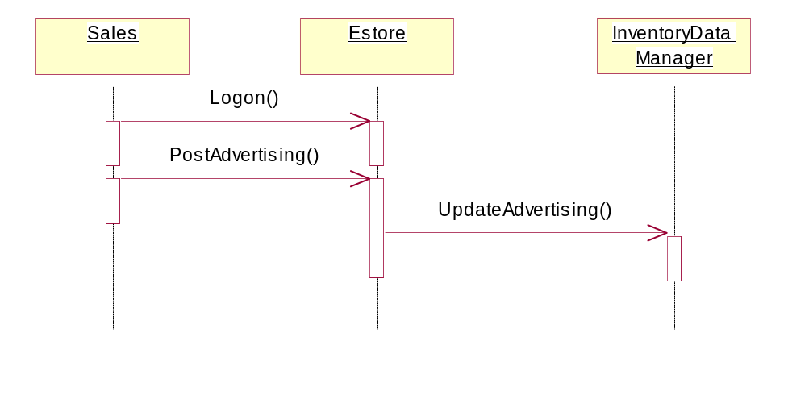
Promotions ( Promotions section (items on-sale) )
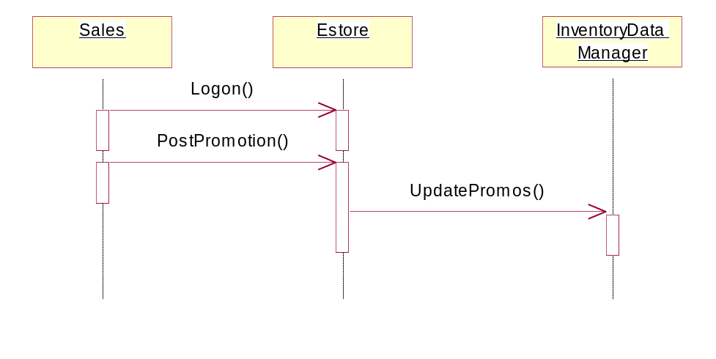
Track Order(Track Shipments Online,Status by Email)
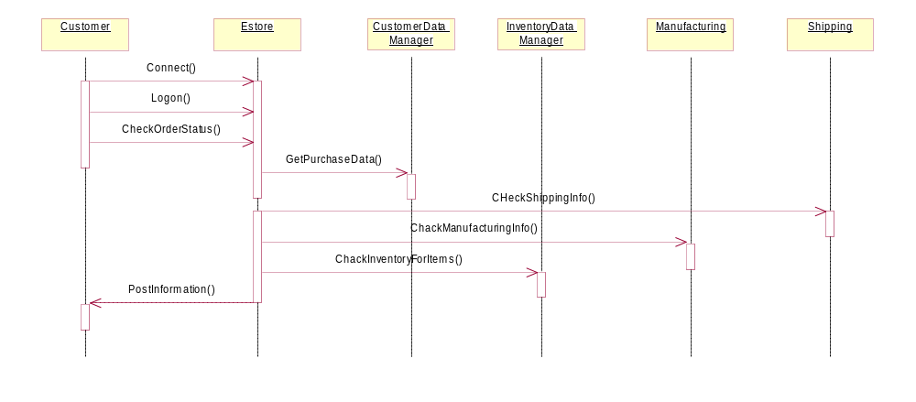

Purchase (E-mail confirmation, Inventory Tracking,Store Billing Info w/ Profile)
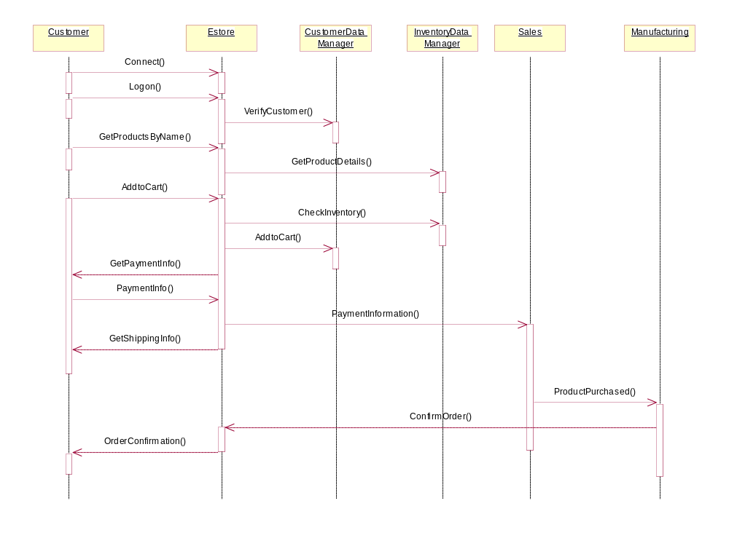
Register(Create Profile,Restration)
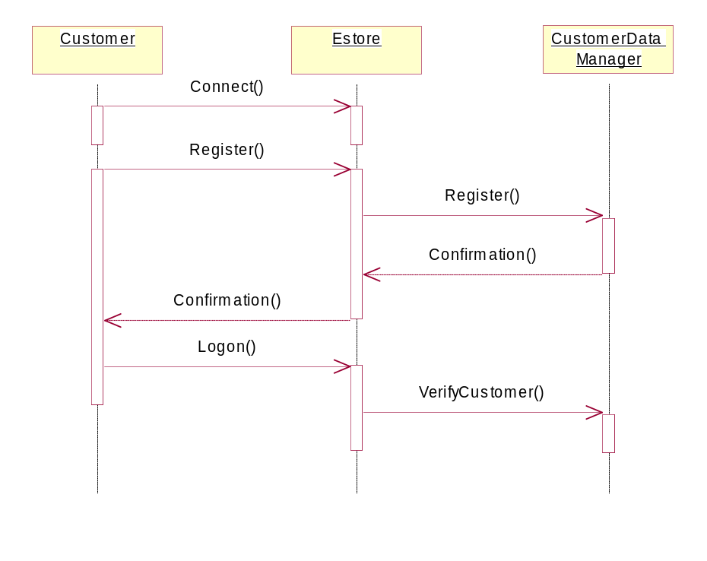

Apply For Credit (Apply for Credit, E-mail confirmation,Financing)
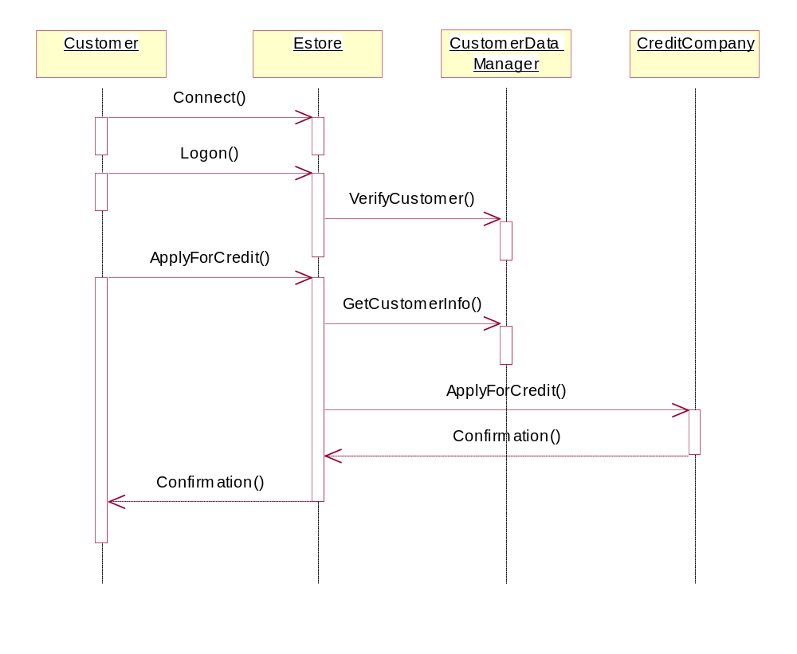
Shipping(Store Shipping Info w/ Profile,Inventory Tracking,Notification to Shipping Dept.,Multiple Shipping Options)
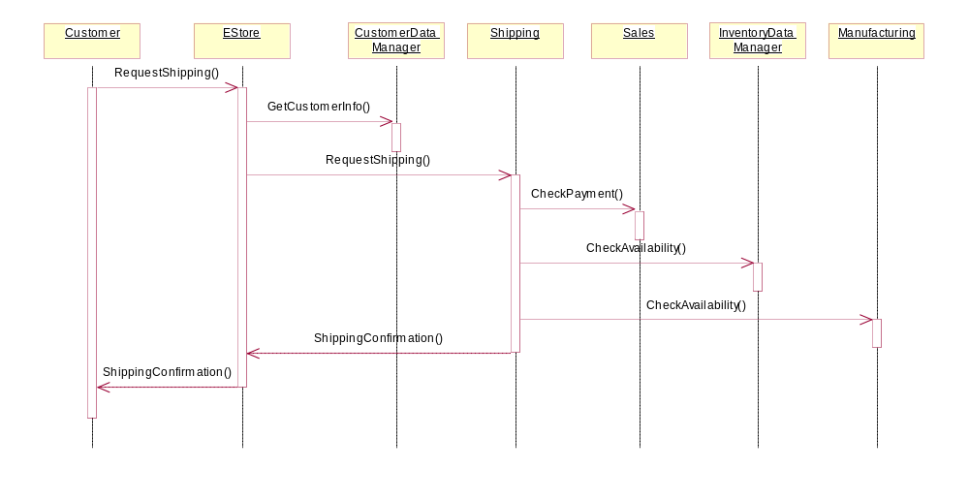

Restock(Inventory Tracking)
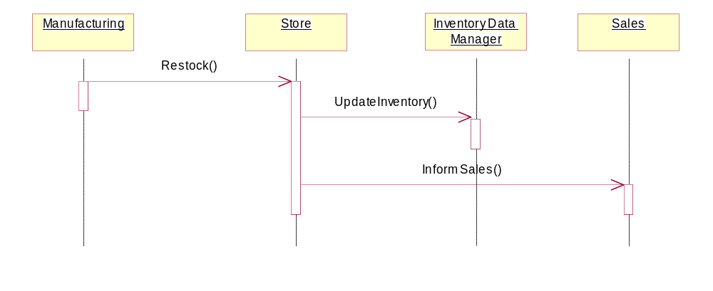

Update Inventory (Inventory Tracking)
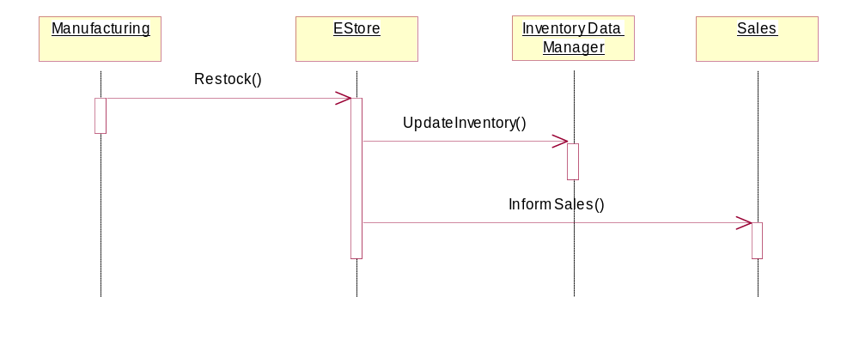

Class Diagram

Below is a high-level class diagram for the MEHE E-Store. This diagram depicts the relationship between different departments within the store, as well as the relationship between the store and the customer or user. One can see the functionality each department has by looking at the associated functions. The multiplicity is also shown to help understand the system better. It is evident that the e-store itself plays a central role in the overall diagram. Most of the functionality passes through it.

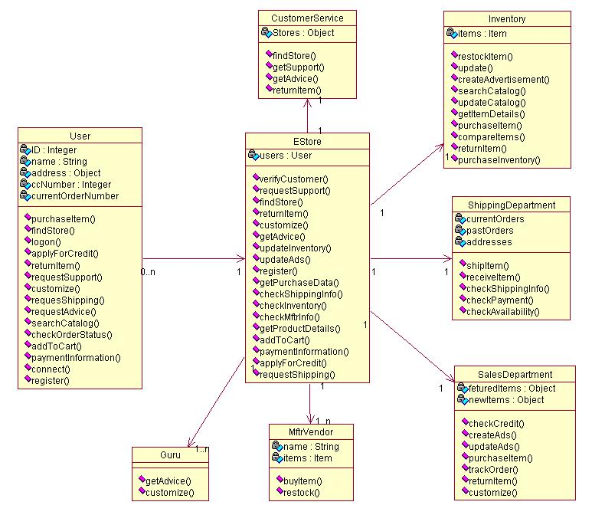

SECURITY

INTEGRITY
COMPLETENESS

CONSISTENCY

ACCURACY

AVAILABILITY

CONFIDENTIALITY

AUTHORIZATION

PERFORMANCE

PASSWORD

USERNAME
INDIVIDUAL PASSWORD
SHARED
PASSWORD
REGISTRATION
_
++
++
+
+
_
+

RELIABILITY

INTEGRITY

AVAILABILITY

COMPLETENESS

EFFICIENCY

ACCURACY

CONSISTENCY
MINIMUM NUMBER OF HOPS
PERFORMANCE (RESPONSE TIME)
++
++
!
PERFORMANCE
CAPACITY
RESPONSE TIME
THROUGHPUT
SPACE
UTILIZATION

COMPRESSED FORMAT
INDEXING
SINGLE LEVEL
MULTI LEVEL
KEYWORD BASED
CATEGORY BASED
IMPROVES RESPONSE TIME
++
+
+

MAINTAINABILITY

TESTABILITY

EXTENSIBILITY

USABILITY

UNDERSTANDABILITY

USER FRIENDLY

MODIFIABLE

AVAILABILITY

BREAKDOWN TIME
+
_
!

++

USABILITY

FLEXIBILITY

CHANGE/CANCEL ORDER

USER FRIENDLY

RELIABILITY

ACCESSIBILITY

LANGUAGE

AESTHETICS

DEFAULT

MULTILINGUAL
+

